ASSUMPTION UNIVERSITY
VINCENT MARY SCHOOL OF ENGINEERING, SCIENCE AND TECHNOLOGY

TAKE-HOME FINAL 1/2026

SUBJECT : CSX4515 - Game Design and Development
ITX4606 - Selected Topic in Introduction to Game Development
LECTURER : Chayapol Moemeng

DATE : Friday 9th October 2026
TIME : 9:00 – 12:00 (3 Hours)

Mark Allocations:
This examination is worth 20% of the total semester score and consists of one part:
Part I: | Game Development | 50 marks
 | Total | 50 marks (20%)

Instructions:
- This exam is open-book and open-internet. Students can use their devices, references, and materials, including Internet searches and AI (ChatGPT, Copilot, Claude, etc.).
- Strictly observe plagiarism regulations. Students’ work must be original.
- Students are not allowed to communicate with anyone regarding this examination.
- Follow the detailed instructions in each part carefully.

Name: I.D. No.: Sec.

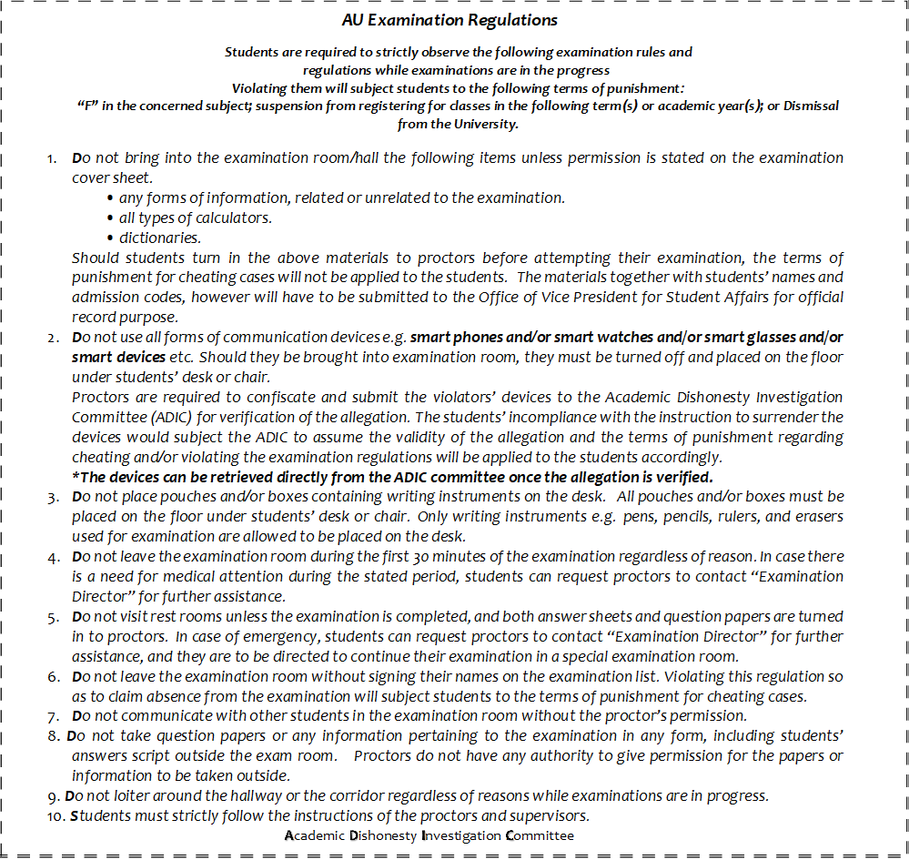
-Total 2 Page (Excluding the cover page)-
Part I: Game development (50 marks – 3 hours)

- Follow the design specification carefully.
- Publish your work in a GitHub repository. If you cannot publish to GitHub, submitting a ZIP file is acceptable, but a penalty will be applied.
- This is an open exam. You may use your laptops, smartphones, any references, or any materials, including Internet searches and AI.
- You must always record the screen. The video serves as proof of work and evidence in the event of any disputes or suspicions.
- You are not allowed to communicate with anyone by any means.

Task: Three-in-One Game
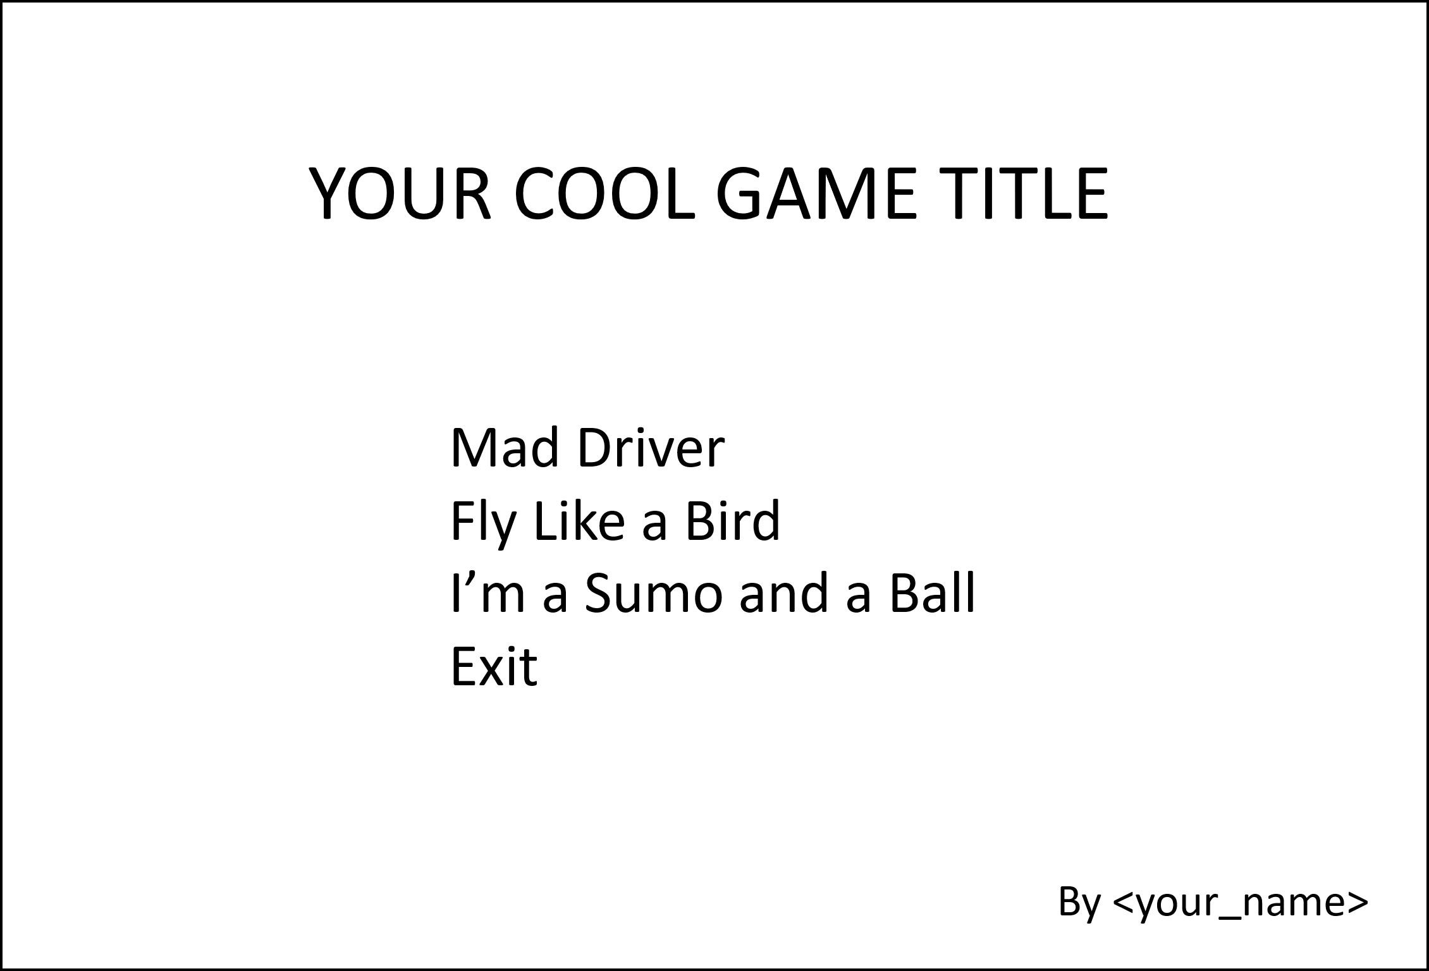
Combine three games: the driving game, the flying game, and the sumo game. Build menu screens to accept the player’s input. Reuse all previous games built in the class. There are two menus: Main Menu and In-Game Menu. Build the menus by using the guidelines shown in the following images.

Main Menu
It allows the player to select a game to play or exit the game.

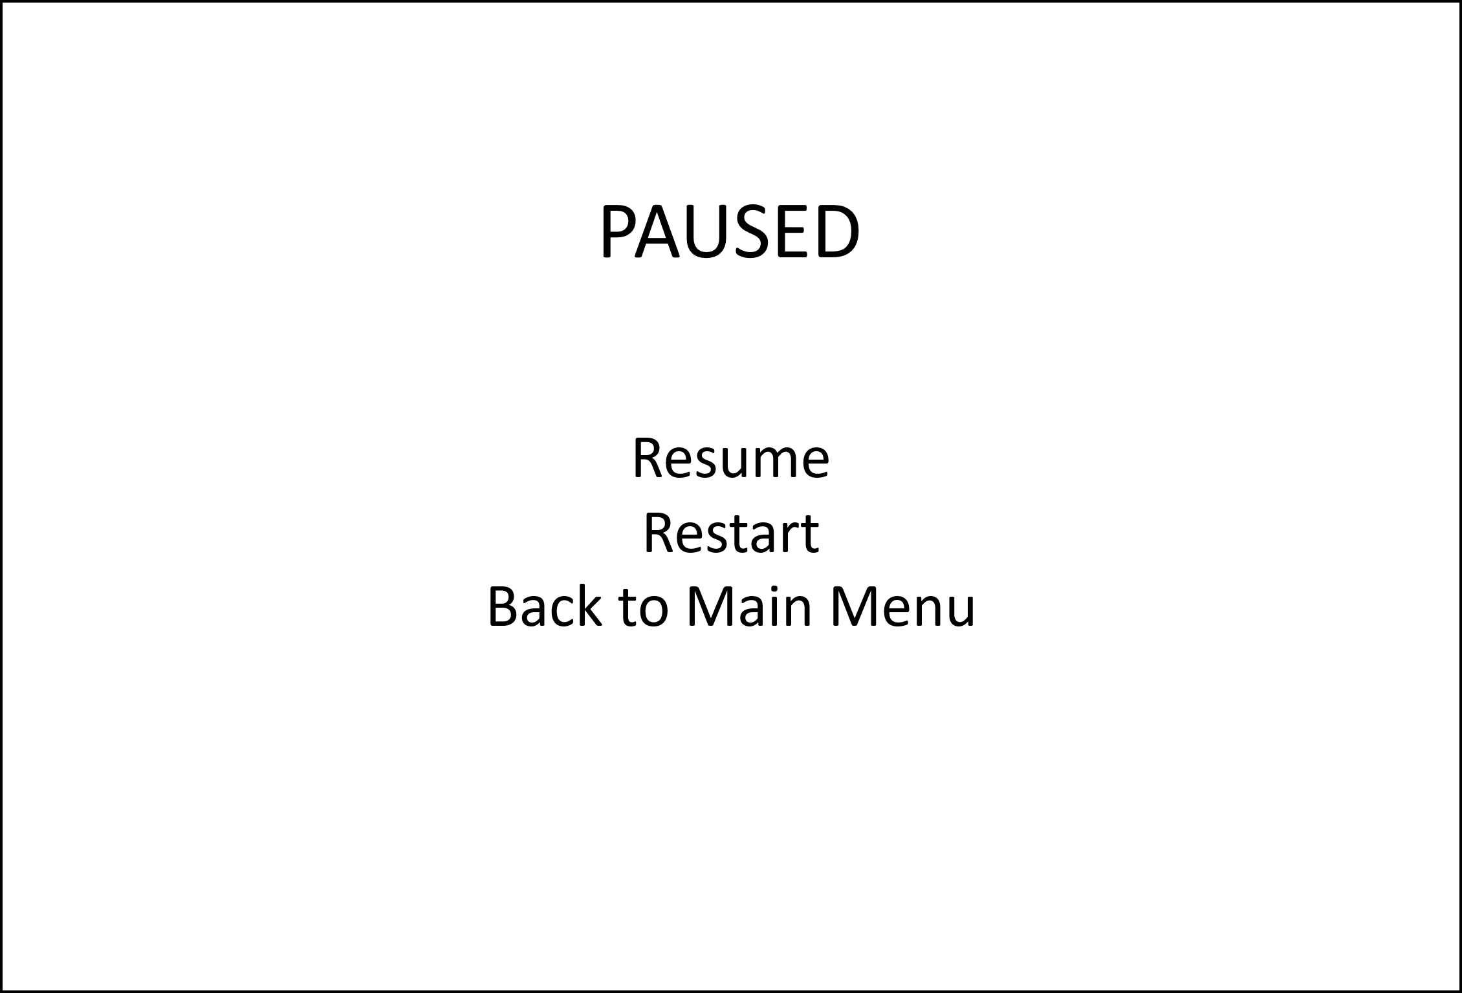
In-Game Menu
In each sub game, when the player presses the Escape key, the game will pause and show In-Game Menu. The menu allows the player to resume the game, restart the game, and navigate back to Main Menu.

In your video recording,
- Show the Git commit & push process of your source code.
- Show the gameplay that demonstrates all required features at the end of the video.

Grading Criteria
- [5 marks] Main Menu design
- [5 marks] In-Game Menu design
- [5 marks] at Main Menu, on select [the driving game], navigate to the playable game.
- [5 marks] at Main Menu, on select [the flying game], navigate to the playable game.
- [5 marks] at Main Menu, on select [the sumo game], navigate to the playable game.
- [5 marks] at Main Menu, on select [Exit], exit the game.
- [5 marks] In the game, on press the Escape key, pause the game.
- [5 marks] at In-Game Menu, on select [Resume], resume the game.
- [5 marks] at In-Game Menu, on select [Restart], restart the game.
- [5 marks] at In-Game Menu, on select [Back to Main Menu], navigate to Main Menu.
Penalties
- [-25 marks] No online repository and no ZIP file submission.
- [-50 marks] There is a change in the source code in the GitHub repository after the exam time.
- [-50 marks] No video recording.

%%%%%%%%%%%%% End of the Exam Paper %%%%%%%%%%%%%%

